**Carolina Simonet**

**Code Smells**

1. Message Chains

Location:

ganttproject/src/main/java/net/sourceforge/ganttproject/gui/taskproperties/DependencyTableModel.java

Explanation:

We are getting an object, and again getting another object back and again calling another method.

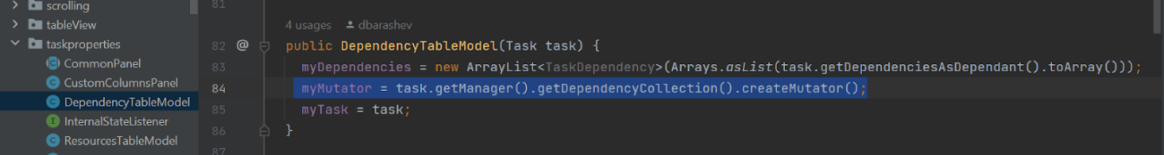

1. Dead Code

    Location:

ganttproject/src/main/java/net/sourceforge/ganttproject/util/StringUtils.java

Explanation:

The code is not used for now, and we already have a similar method padLeft.So we could delete this method.

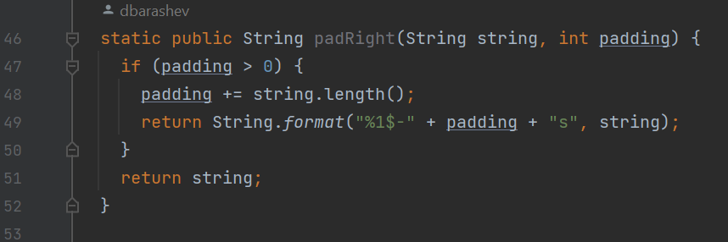

1. Long Method

Location:    ganttproject/src/main/java/net/sourceforge/ganttproject/task/TaskProperties.java

    Explanation:

This method is very long with 79 lines and it’s confusing to understand it because it has a lot of if statements and no comments. The method is       responsible for doing more things than it actually should.

